How To Handstand: The Complete Beginner’s Guide

The handstand is an amazing skill that is very versatile when it comes to body weight training. A lot of calisthenics exercises, progressions and transitions revolve around this fundamental skill.
There is also this other thing...
​Handstands are incredibly good for you!
​Handstands are great for getting the blood flowing. They will help improve your coordination, balance and will test your strength too.
​It may not take long to learn how to handstand, to be able to get up into position and hold it, but it is going to take a lot of training to master.

On This Page You Will Learn . . .
- How To Handstand
- How To Get Out Of A Handstand Safely
- Handstand Progression Exercises
- Tips On Handstand Training And Technique
- Variations Of Handstands For You To Try
- Handstand Transitions That Will Challenge You In A Whole New Way

FREE Handstand Training Workout!
Get Started With Handstand Training Today With This Simple Workout You Can Do Anywhere
The simplest way to handstand is stepping in and kicking up. Levering is difficult and requires a lot of flexibility and strength, but a handstand does not.
​When you handstand, like when you stand normally, everything is stacked up in a column, one on top of the other. Your muscles mainly play a supporting role for balance.
​When you step up you are kicking yourself straight into that supported stack and working to balance once you get up there. Levering up takes a lot more effort and you still have to balance once you are in position.
​For this reason a stepping handstand is the quickest and easiest to learn, and requires the least strength, worry about the lever skills later when you can balance.

Step 1 - Position
​Start with your hands high stretching up against your ears with one leg straight out in front of you.
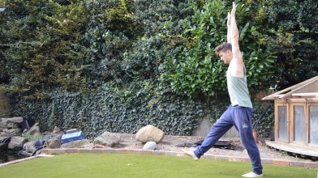

Step 2 - Step & Stretch
​Step onto your front leg and take a big stretch to the floor with your hands.
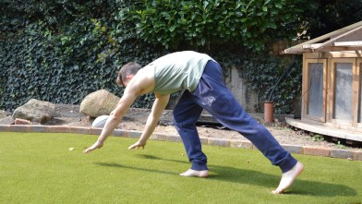

Step 3 - Kick Up
​Swing your back leg up to 12 o'clock, keeping it straight, and kick off with your other foot.
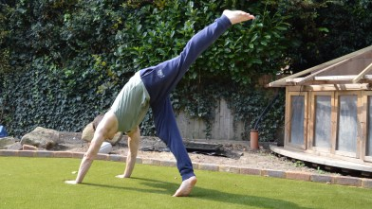

Step 4 - Stack & Tighten
​Bring your other leg up fast, pointing your toes to keep your legs straight and tight.
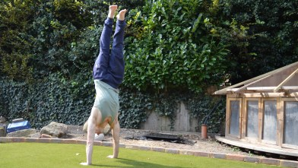

Step 5 - Stabilise
​Stretch high off the ground to keep everything stacked and tight, maintain balance with your core and wrists.
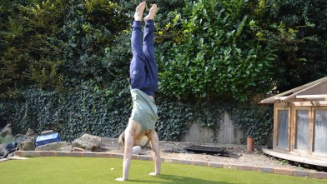

Step 6 - Dismount
​Inevitably, you will have to get out of the handstand at some point, you cant stay up there forever! Depending on which way you are overbalancing, there are a few different ways to get out of the handstand without risking injury or embarrassment.ting Yourself
​Getting out of a handstand, we'll call it a dismount for ease, can be awkward and dangerous if you aren't careful.
​There are 3 very simple ways of dismounting from a handstand without risking serious injury or face planting straight into the floor. You will use a different dismount for different situations so it is worth learning them all. But don't worry, they are all very simple and will become second nature very quickly.

Dismount 1 - Step Down
​The first dismount is simply stepping back down the way you came up. Your feet will come down towards the floor and land safely, no twisting or rolling required. This is the dismount to use if your balance brings you backwards.
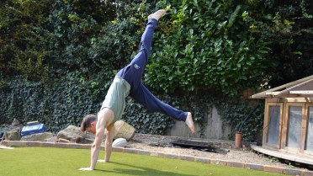

Dismount 2 - Turn & Plant
​If your balance takes you out to the side, or you are leaning out at a funny angle, use this dismount.
​Your dominant hand - the one you are leaning on more - stays firmly planted on the ground, and the other one lifts off as you turn to cartwheel out. Plant the closest leg - dominant side - as your hand lifts up and stand up tall out of the handstand.
​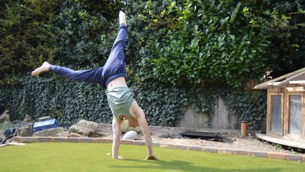

Dismount 3 - Roll Out
​This dismount is probably my favourite, just because it's kinda fun. But it is also great for developing longer handstand holds. This dismount can be used when you are leaning forwards in your handstand, making the turn out or step down impossible.
​To do a roll out, as you lean forwards, bend your arms to bring your head towards the floor. Tuck your head into your chest and roll from your shoulders down your back into a seated position on the floor.
​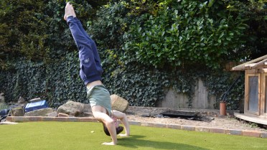
Learning these dismounts and DRILLING THEM is a surefire way to get more confident with your handstand. ​
​Progression 1 - Wall Support
​The Wall Support is as simple as it sounds. All you are doing is kicking up against a wall and using it to support your body in the handstand position.
​This will help you learn the handstand position for when you do it without support. It is important to get inverted time in. Being upside down is weird, you need to get comfortable before you can pin good handstands.
​

Progression 2 - Step In
​The next step is moving away from the wall. Naturally when you are flinging yourself up against the wall you will be a bit clumsy, you need to tighten it up.
​Step In refers to the first part of a handstand. When you kick up, keep your back leg at 90 degrees to your body and only bring your leading leg vertical.
​The more controlled you can make this, the faster you will be able to develop your full handstand.
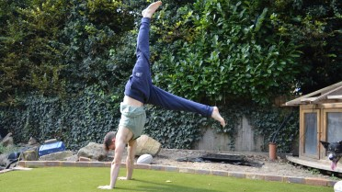

Progression 3 - Roll Outs
​The biggest struggle I see with people learning to handstand is confidence. They are afraid to kick up properly because they don't feel safe upside down. To build confidence you need to know you can get down safely and you wont hurt yourself.
​Starting with forward rolls and building up to more extended, straighter body rolls, will teach you to roll out from the handstand.
​Do 10 of them, starting with forward rolls and building out to a handstand roll out by straightening your body more each time.
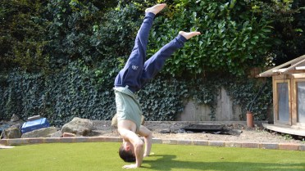

Progression 4 - Walking
​Once you can get in and out of a handstand, you need to build the stability and coordination to hold it.
​For me, that starts with building handstand time by walking. Not in any particular direction, just get up and move your hands about to maintain balance and keep the handstand as long as possible.
​You will learn to feel your balance point and it will help you stay up a lot longer than by being stationary, making you stronger and more comfortable inverted.
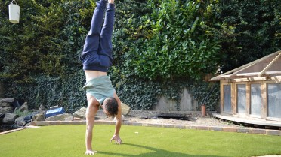

​Once you can kick up, you will probably want to try out a few other handstand variations. Straddle and Press exercises are great starting points. But there are other ways to balance and hold a handstand that you can use .
​Variation 1 - Straddle
​The Straddle variation of the handstand is simply a side split. The straddle position refers to this split in your legs, as opposed to a front split.
​Using the straddle position will help improve you balance and get you on your way towards the ultimate One Arm Handstand!
​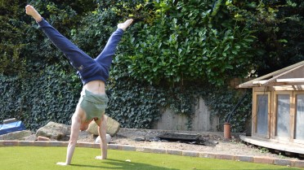

Variation 2 - Straddle Press
​Handstand press exercises are not push ups they are levers. You plant your hands on the floor and lever your body up, unfolding into a handstand. They require a lot of strength and coordination and will take your handstands to the next level.
​Start with your feet apart to straddle up. Keep your elbows locked and lever from the shoulders.

Variation 3 - Pike Press
​The pike press is another handstand press variation where you have your legs together.
​This variation is harder than the straddle because the lever is bigger. You need to lean further forward when you start the press, and focus on pointing those toes and keeping nice straight legs.
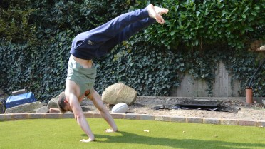

Variation 4 - Tuck
​Tuck handstands are fun and easy, they will help improve your position in the handstand by encouraging your shoulders to open right up.
​Start tucked on the floor and kick your legs up together. Stay tucked all the way up into the handstand and hold for time.
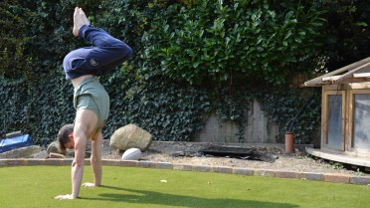

Variation 5 - Split
​The split variation is like a straddle, but you split front-to-back rather than side-to-side.
​When you kick up, keep your trailing leg back and lean your front leg past vertical. Your trailing leg will naturally come up to balance, focus instead on good upper body positioning and use your legs to maintain balance.
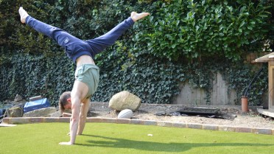
Getting into a handstand is one thing, but holding it solid enough to learn push ups is a whole new challenge. You need to develop a certain degree of stability to be able to progress to harder variations and skills.
​From hands to toes there are a few little tweaks you can make to your handstands to improve posture and make balancing easier. I found I was doing a whole host of things wrong when I started. My hand positioning was wrong, my shoulders were misaligned and my legs were all over the place.

Lock Those Arms
​Handstands should be done with straight arms. Being in this position actually makes it easier because you are creating a stable support for your body rather than taking the load on your arms.
​In comparison to your knees, which are surrounded by massive muscles, your arms create small weak levers when they bend, forcing your biceps and triceps to do a load of work to keep you up.
​As soon as you bend your elbows you are taking the weight onto your arms and you will naturally come straight down.
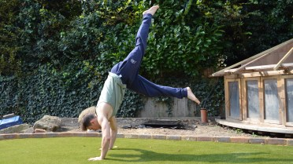

Close Hands
​Keep your hands close and your shoulders narrow. You may naturally put your hands down wider, but that is the equivalent of standing with your legs wide apart.
​Standing wide forces your muscles to do a lot more work to keep you up, and makes balancing a lot harder. Stack your body in a nice straight line rather than spread out, with your shoulders close in to your ears.
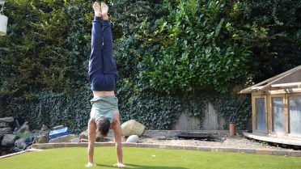

Stretch Up
​Drive your hands into the ground and stretch everything else up off the ground.
​Extended everything high off the ground will help to tighten up your muscles and improve balance. Pointing your toes will engage your legs too, stopping them from waving around.

Grip The Ground
​In then handstand position, you want to be gripping the ground with your hands, holding on to it with fingers spread.
​

